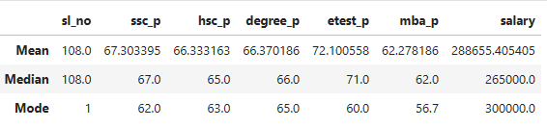

**Summarization of the data:**

The students perform similarly, with everyone from 10th grade to master's degree getting an average mark. In the entrance test, they scored an average of 72. I discovered outliers when looking at the median salary and noticed that the mode values in each column are as follows: 10th grade – 62, 12th grade – 63, undergraduate (UG) – 65, entrance test – 60, postgraduate (PG) – 56.7, and salary – 3L.